Around the World on a Fiddle (suitable for all ages)

Saturday, March 25, 10:30 AM - 11:30 AM

Trehaus, 442 Orchard Road, #03-01 Claymore Connect, Singapore 238879

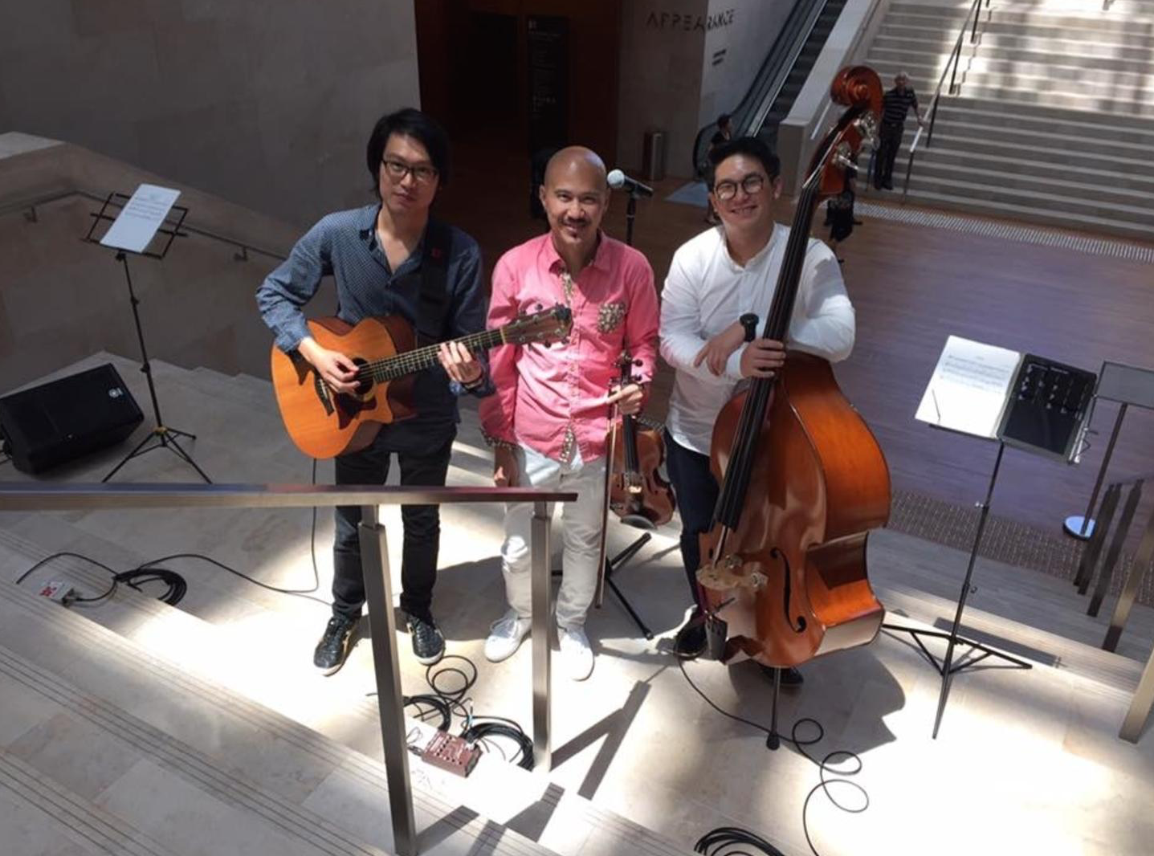

Come take a trip through cultural time and space with KailiFiddler For Peace Kailin Yong and his friends as they present a mesmerising program of folk music around the world showcasing the sonic and cultural versatility of the violin (also known as the fiddle). Featuring Kailin Yong (Violin), Sebastian Ho (Guitar) and Felix Phang (Bass).  
  
- Short introduction and welcome   
- Brief history of the violin and its unique journey around the world   
- The band will play a colourful program of music from different cultures; from Asia to the Middle East, from Europe to the Americas   
- Between songs, a presenter will give a brief description of the different tonalities and rhythms commonly used in the folk music of each country and tradition.   
- Volunteers will be asked to identify the countries of origin of a few pieces of music played by the band.   
  
Kailin and his band will teach children unique rhythms from different parts of the world and encourage them to clap along with the songs and sing along with the choruses.

